FOUNDATION FOR VIRTUAL AND AUGMENTED REALITY SYSTEMS
Lecture37
Lec-37: Usability requirement gathering and specification
Hello and welcome to the NPTEL MOOCs course on Foundations for Virtual and Augmented Reality Systems. We will continue our discussion on requirement gathering. Along with that, of course, we are going to talk about specification, analysis and specification of the requirements. So, in the previous parts of this lecture, we talked about methods, different methods for gathering end-user requirements.
Just to recap, here we are talking about end-user requirements, not necessarily the client requirements. And since usability is a prime concern here, end-users who are supposed to be laypersons, who do not have much knowledge or interest in how the system works, their requirements should be taken into account while building the system. That is what user-centered design suggests. So, essentially the objective is to ensure usability of the end product.
Now, we talked about or we started our discussion about one such usability requirement gathering method called contextual inquiry. We talked about different aspects namely what it is, what are the stages, how to analyze the data and so on. Now, we are going to continue our discussion on contextual inquiry and also in this part of the lecture. We will discuss our case that is the Majuli VR Tour in light of whatever we have discussed so far. Now, in the previous part of the lecture we stopped at our discussion on how to use the outcome of the contextual inquiry.
So, there are different ways. to utilize the outcome. One is, of course, the design guidelines or design recommendations or design principles that we can suggest based on our findings during contextual inquiry. We have already seen some examples of that. Also, we can utilize the same outcome to create functional requirements.
Now, functional requirements are those where we specify the requirements in terms of functions where there is a well-defined input, well-defined output and these types of functional specification of requirements make them easy to convert to code. So, from there to transition to code design becomes easier if we are able to convert our requirements into functional requirements. So, that is also possible when we are talking about outcomes obtained through contextual inquiry.
Now, we are discussing one particular example: a note-taking application. So, let us see how we can utilize this outcome in the form of guidelines first, and then we will see how we can convert the outcome into some sort of functional requirement. So, on guidelines, we can frame some guidelines based on observations as we have seen earlier also. Say, for example, we have discussed in the previous part of the lecture the outcome in terms of groups with headers, say overall scheduling
then there are two data items, two notes taken during observations which fall under this overall scheduling group and from here what we can do is frame a guideline, say for example, guideline 1 which says the app should support viewing of upcoming deadlines for assignment submission for the current day and also for the next 7 days. This is One guideline that we can frame. Another guideline we can frame guideline 2 which is the app should support viewing of scheduled meetings for the current date.
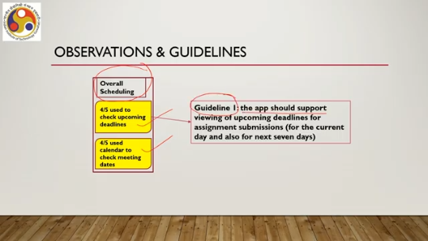
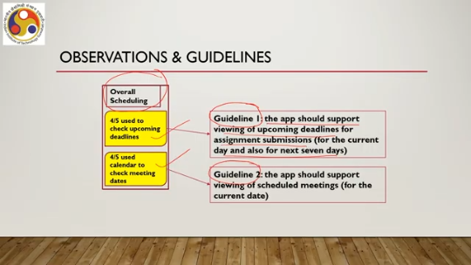
This is based on whatever we have observed during the data collection phase. Similarly, we have another group of items; the group header is day-wise scheduling. And there are three data items, three notes we have taken. So, based on these three data items within this group, we can frame guideline 3, that is: the app should support viewing of the timetable on any given day. Now, it is talking about guidelines for what the app should do or should not do.
It is not telling how to do it. So, keep that in mind. Then we can have guideline 4. That is: the app should support viewing of lecture schedules on any given day. So, these are some of the guidelines we can frame based on whatever we have observed.
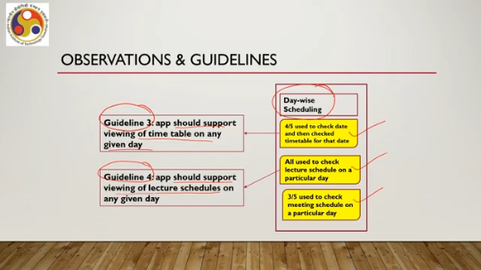
So, these are quite generic in nature, and they tell us that because we have observed those behaviors in the context of use, we should include them in the overall system. So, that is how we are ensuring that the user is involved in the design, based on observations and feedback. Now, those are guidelines which we cannot immediately convert to code. We have to use some other trick. As opposed to that, we can have functional requirements specified with respect to the outcome that we have obtained from contextual inquiry.
So, we can also determine functional requirements based on the observations in addition to whatever is found through functional requirement analysis. So, here I am assuming that you already have some idea of functional requirements as we did not discuss that in detail here. So, in functional requirements typically requirements that are expressed in terms of functions which are essentially black boxes, We have well-defined input and well-defined output and we assume there is a function which converts the input to the output. So, already that is done for a system.
In addition to that, when we are talking about non-functional requirements such as usability requirements, we can also convert them to functional requirements. So, we can also add those functional requirements to the already obtained set of functional requirements that we got by performing functional requirement analysis. So, this type of specification in terms of functional requirements allows us to directly incorporate the usability requirements in the system through code that implements the functional requirements. So, when we specify a system in terms of functional requirements, essentially that helps us convert the requirements into code. So, essentially that helps us in code design.
So, if we are able to convert usability requirements to functional requirements, then certainly that will be the best way to go to the next stage, which is the code design phase. Since we are talking of functional requirements, let us have a quick discussion on what these are and how these are specified. So, Already we have noted earlier that usability requirements are one type of NFR. There are many other types as we have noted earlier, which is very important for interactive system design. These are all things we have already discussed before.
Now, NFRs are of course important, all NFRs including usability requirements, but they are difficult to formally specify for implementation. Again, this we have already mentioned earlier. One thing in any software system development is that system requirements should be easy to understand and implement as code. Now, this requires some formal way to specify the requirements. First of all, we have to identify the requirements and also to specify the requirements.
So, that brings us to the notion of functional requirements. Such requirements, Which can be formally specified are generally termed as functional requirements or in short we can call it FR. So, they are easy to convert into code. As the name suggests, FR specifies the system's features or the requirements of a system in terms of functions which essentially consider the input, and output plus the overall purpose of the function.
Now, when we put requirements in textual form, we get what is called the software requirements specification or SRS document. This is a document for specifying the requirements, all sorts of requirements, functional as well as non-functional. Now, it includes functional requirement specification, which is the formal representation or specification of requirements. Generally, the convention followed in SRS is the hierarchical structure of requirements.
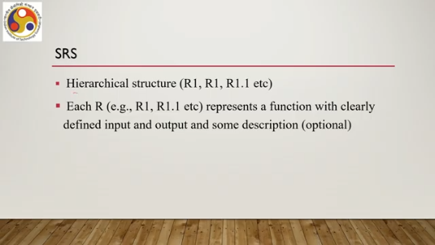
Say for example, at the top level we can refer to it as R1. As R, then R1 is the next level, then R1.1 in the next level and so on. So, each requirement or R such as R1 or R1.1 represents a function with clearly defined input, output, and some description which is optional. Description means what it does rather than how it converts the input to the output. Now that is a brief idea.
So, we have functional requirements where we specify any requirement R in terms of a function f with some input which converts the input to some output which is what we require. So, when we specify functions in the SRS document, we need to provide the input. We need to provide the output and optionally we need to provide some description. And this is generally represented in the form of a hierarchy, say top level function, then level below it, then level below it and so on. Some sort of hierarchy.
Now with that basic knowledge, let us quickly revisit the example. So, we have talked about some guidelines that we obtained based on contextual inquiry in terms of the example we are discussing, that is calendar app for college students. Now, there we saw how the guidelines can be framed. Now, let us try to see whether we can convert the outcome to functional requirements which are amenable to specification in the SRS so that those are easy to convert to code.
So, for example, one functional requirement can be views, different views that can be obtained where the input is date and depending on date the views are generated, output is specific view such as timetable, submission deadlines, meeting list and so on. And here the description can be: in this function, the user can check day-wise timetable of lectures, upcoming assignments, submission deadlines or scheduled meetings. Note that how we converted the findings in terms of a function. Similarly, we can have another function under view that is timetable view.
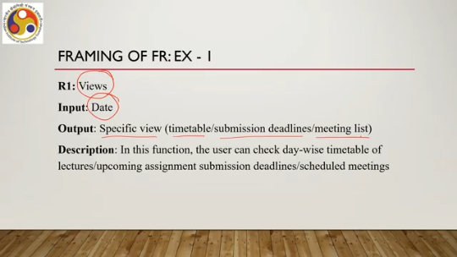
Note that it is below, R1, so it is denoted as R1.1. The input remains the same: date. The output is more specific. That is timetable for the day.
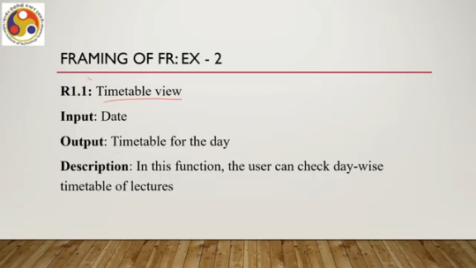
Description is: in this function, the user can check day-wise timetable of lectures. So that is optional, of course, but it is always good to provide the description so that the purpose is known. So when somebody reads the document and then tries to write code for that function, more clarity is there. Then we can have another under view. So, we have R1 view under which we have R1.1, then R1.2, and so on.
So, R1.2 can be deadline view. Input is date, output is submission deadlines. So, in this function, the user can check day-wise assignment submission deadlines. Then R1.3 can be meeting schedule, input date, output is list of meetings scheduled on the day. So, we have R1, R1.1, R1.2, R1.3.
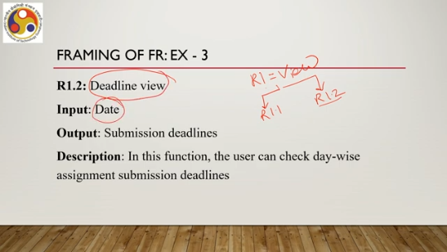
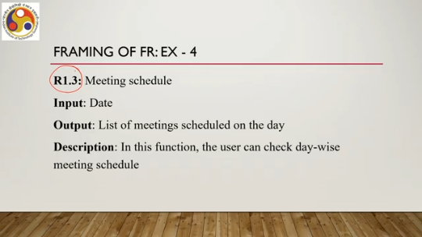
R1.3. Now R1.3 is meeting schedule input remains the same output is list of meetings scheduled on that day and description the user can check day-wise meeting schedule in this function. So that is briefly how we can utilize the output obtained through contextual inquiry. Now output is in the form of group-wise organization of the notes taken during the observation.
That output either we can convert to some design guidelines to ensure usability or some of them if not all we can convert to functional requirements so that those are directly implementable as code. So, that is about contextual inquiry what it is, how it can be deployed to identify usability requirements and the identified requirements can be utilized either in the form of guidelines for subsequent design stages or functional requirements which can be converted to code. With this knowledge, let us now come back to our original case study that is Majuli VR Tour Design.
So, here the first stage is, of course, as we discussed: requirement gathering, gathering usability requirements for the users, for the tour. So, earlier we talked about the basic idea of usability requirement gathering, also how to analyze and specify. For analysis, we talked about the affinity diagram method; for specification, we talked about functional specification. Now, let us try to understand this knowledge, how it can be useful in the context of the Majuli VR Tour. So, in order to identify the requirements, what we did is we made several field trips to Majuli, interviewed people, observed people in their natural work settings, and collected the data.
The data that we discussed earlier, which is in terms of notes, we collected data. One thing to be noted here is that the system is not necessarily meant for only the people who are residing on Majuli. In fact, they are least likely to use it because they are already there. It is meant to be used by those not residing on the island. So, we have to keep that in mind.
Our users are not necessarily those who are on the island, but rather those who are not on the island. So, through the field trips, interviews, and observations, we have identified three potential user groups who would be interested in experiencing the VR tour. One group would be students or learners, those with an interest in knowing about the island. Another group would be tourists. They are interested in exploring tourist spots or other interesting places on the island.
And thirdly, pilgrims who are interested in the religious practices, those who are interested in the religious places and in the religious practices. So, we have identified these three groups: students or learners, tourists and pilgrims based on our interactions and observations. during the field trips. So, after interacting with people, we got this idea and utilized their experience about the visitors who come to the islands, what they typically do, who comes, what they typically do, these types of information we obtained after interacting with the people there on the island and based on that we have identified these three groups.
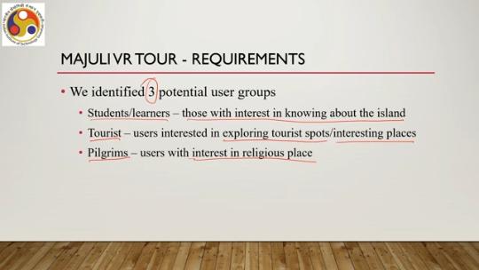
So, that is the first stage, that is know the user. So, we are targeting a usable system that is Majuli VR Tour meant for these three categories of users. Note that we are not claiming that our system will be usable to anybody in any work context for any task. We are assuming that it will be usable only for these three groups of users. Then, once the user groups were identified, we conducted contextual inquiry on the chosen user group samples,
from the user groups to learn about their needs and expectations from the system, which helped us identify the system features to be supported for each group so that the system is usable for each group of users. So through this process, we managed to address a few key design challenges. Key challenges that we have listed out earlier. What are those challenges?
So, coverage of large geographical area, we have large multimodal data to provide comprehensive view because the nature of the data and geographical area is huge. It is time consuming to explore the entire island with all the data that we have collected which may lead to cyber sickness. So, how to avoid cyber sickness was one of the key challenges which we could address following the requirement gathering method. So, essentially how did we address the challenge?
We used a subset of data to be viewed by each group. So, there are three groups, not all groups are supposed to access the entire set of data that we have collected. Instead, each group is supposed to access only a subset of the data. And this subset is identified through the contextual inquiry, which kind of things they do. And based on that, we decided what kind of data should be made accessible to each group of users.
So the subset idea reduced the cyber sickness possibility because it reduced the expanse of information for each group, as well as the need for exploring everything in detail. And also that, in a sense, helped in increasing interest for each group. If we had not done so, if the entire data set is accessible to all users, then the users would be confused. They will be at a loss on what to see in detail, what to skip and so on. Then that would have affected their interest in the system as well as may have led to cyber sickness.
Another thing is location awareness, one of the key challenges. In any VR tour, ensuring users have accurate location information is very crucial so that there is no disorientation happening. Particularly important when dealing with large geographies, users should be made aware of where exactly they are in that geographical space so that it gives more confidence and more purpose to the user and how could we ensure that. So the issues that are likely to be faced by a user when they are exploring a large space, we have identified issues during the contextual inquiry phase that location awareness actually is an issue.
And we addressed this issue by adding a location awareness feature which we will be discussing in a later part that is dealing with the design of the system. So here we have just identified the issues. And possible guidelines on how to resolve it and later on during the design phase we have converted those things into these functional requirements. A third issue challenge is tangible and intangible heritage experience. So, earlier we mentioned that
we need to provide both tangible and intangible heritage experience to the user. How to combine the tangible and intangible for a seamless experience? That was another key challenge. So if we break it down, another challenge is interaction aid for enhanced user experience, which includes navigation support to cover large geography, user-friendly interfaces, and how to increase presence.
So along with tangible and intangible heritage, we also needed to provide support for interaction to improve the user experience, which includes navigation support, user-friendly interfaces and increase of presence by providing natural interactions. Now these are, of course, even without CI we could identify these things, but those are broad in nature; specific issues for specific user groups in relation to those challenges were identified during the contextual inquiry phase. And based on that, we proposed novel methods and techniques to address tailored for specific user groups, but those come under design.
So, we will be discussing exact solutions in a subsequent lecture on the design of the system. So, in summary, what we can say is that in this lecture, we learned about the idea of usability requirement gathering, why it is important and how it is different from, in general, usability in the general requirement gathering phase. Also, we talked about analysis, how to analyze the requirements and specifications. Now, all these discussions took place with respect to one of many methods available for usability requirement gathering, that is contextual inquiry, only one of many methods.
So, we talked about contextual inquiry stages. We talked about the nature of data we obtain through contextual inquiry, and we talked about how to analyze that data using the affinity diagram method and, finally, how to utilize the outcome, the result of the analysis, so either in the form of guidelines or in the form of functional specifications. Then we talked about how we did the contextual inquiry and what we found when we were talking about the case that we have introduced earlier, the case of preserving digital heritage, preserving heritage digitally for the Majuli River Island.
So, we saw how this approach helped us identify and address challenges to make the system usable. So, essentially in this phase we did not talk about addressing the challenges rather we talked about how or what issues we identified through contextual inquiry in terms of user groups and their requirements. So that is about requirement gathering and its application for building the Majuli VR tour. Now we have identified several issues as we have discussed; how we address those issues in the design phase that we are going to discuss in the next lecture
there we will be talking about the fundamentals of design when we are talking about usable systems and key design elements that we have added to the virtual tour to address the challenges or issues identified in the requirement gathering phase. So, the materials that I have utilized to discuss the topics for this lecture are taken from this set of references. You can go through these references for more details on each of these topics. So, for example, I skipped discussion on functional requirement assuming that you already have some idea, but if you do not have the idea,
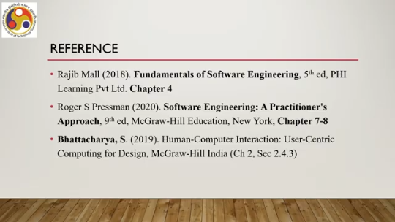
to go through any book on software engineering or even the third one on HCI where some discussion is there on functional requirement as well. So with that we conclude this lecture on requirement gathering, analysis specification and how the knowledge is utilized for the Majuli VR tour design. Looking forward to meeting you in the next lecture on design. I hope you are able to follow the topics and the discussions. So until the next lecture.
So, looking forward to meeting you again in the next lecture. Until then, thank you, goodbye, and happy learning.

